Note to Partner
Please update fields highlighted in red in advance of sending to your network, including URL links to dedicated Sprintax landing pages.
Suggested text for J Partners to post on their website or mail to their international population:

- Summary of those eligibile for Economic Impact Payment:

- Are a US Resident for tax purposes
- Have filed a resident tax return (Form 1040) in 2018 or 2019
- Will be considered a qualifying resident alien for the 2020 tax year
- Have an Adjusted Gross Income of between $75,000 and $99,000 (increasing for head of household and married filing jointly)
- Possess a valid social security number
- Not have been claimed as a dependent on another person's tax return

For more information, visit the IRS Economic Impact Payment pages:
  - https://www.irs.gov/coronavirus/economic-impact-payment-information-center
  - https://www.irs.gov/coronavirus/economic-impact-payments

- Key area of confusion for J Program participants: Resident v Nonresident for tax purposes
  - Based on IRS Substantial Presence Rule – Most J program participants in the US are nonresidents in the US for tax purposes
https://www.irs.gov/individuals/international-taxpayers/substantial-presence-test)

Complete the Substantial Presence Test for free with Sprintax
https://www.sprintax.com/?utm_ref=covidpartnersinfo

- Misfiling and filing as a resident by mistake
  - Significant number of J program participants make the mistake as filing as a resident for tax purposes
  - Most tax services (Turbotax, H&R Block, Tax Act, local CPA’s etc – are designed to help residents – not nonresidents – not international students and scholars
  - Filing incorrectly means you are claiming benefits and deductions you are not entitled to
  - TurboTax specifically say they cannot help nonresidents

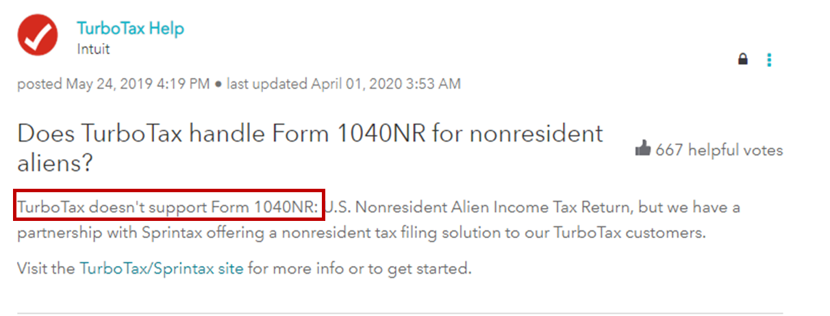

DO NOT USE A RESIDENT TAX RETURN PREPARATION SERVICE UNLESS YOU ARE CERTAIN THAT YOU ARE A RESIDENT FOR TAX PURPOSES

- Recommended next steps:
  - If you have received the Economic Impact Payment (stimulus check)
    - Check what tax return you prepared in 2018 or 2019
    - Was it a 1040 (for residents) or a 1040NR (for nonresidents)?
  - If it was a 1040 you filed as a resident for that year:
    - Log in to Sprintax
    - Sprintax will guide you through the substantial presence test and confirm if you were a resident or nonresident for that tax year
    - If you filed as a resident and Sprintax confirms you are a resident – no further action required at this moment
    - HOWEVER – If Sprintax finds that you are a nonresident then you should have filed as a nonresident – you need to prepare and send an amended tax return (1040x) to the IRS to correct this
  - Sprintax will help you prepare your amended return, for any year
    - We recommend you do this as quickly as possible
    - Once you have your Sprintax amended return, mail this to the IRS.
    - Separate to your amended return – return the stimulus payment. The IRS provide instructions here:
https://www.irs.gov/taxtopics/tc161

- Future implications:
  - You have not paid the correct amount go tax to the IRS - filing an incorrect tax return may cause fees and penalties to accrue with the IRS
  - Incorrect tax filing will also impact a change of visa status or a future visa application – so please ensure now that you have prepared your taxes correctly for 2020 and previous years.

<J PARTNER> has partnered with Sprintax – a specialist nonresident tax provider who helped more than 20,000 J visa holders with their 2018 and 2019 taxes.

If you are not using Sprintax – make sure you understand if you are a resident or non-resident for tax purposes and that you are not filing incorrectly.

