Note to Partner
Please update fields highlighted in red in advance of sending to your network, including URL links to dedicated Sprintax landing pages.

Suggested text to post on website or mail to your international population:

- Summary of those eligible for Economic Impact Payment:

- Are a US Resident for tax purposes
- Have filed a resident tax return (Form 1040) in 2018 or 2019
- Will be considered a qualifying resident alien for the 2020 tax year
- Have an Adjusted Gross Income of between $75,000 and $99,000 (increasing for head of household and married filing jointly)
- Possess a valid social security number
- Not have been claimed as a dependent on another person's tax return

For more information, visit the IRS Economic Impact Payment pages:
  - https://www.irs.gov/coronavirus/economic-impact-payment-information-center
  - https://www.irs.gov/coronavirus/economic-impact-payments

- Key area of confusion for international students and scholars: Resident v Nonresident for tax purposes
  - Based on IRS Substantial Presence Rule – Most international students and scholars in the US are nonresidents in the US for tax purposes
https://www.irs.gov/individuals/international-taxpayers/substantial-presence-test)
  - Small number may be here long enough to be considered tax residents by IRS

- Misfiling and filing as a resident by mistake
  - Significant number of international students and scholars make the mistake as filing as a resident for tax purposes
  - Most tax services (Turbotax, H&R Block, Tax Act, local CPA’s etc – are designed to help residents – not nonresidents – not international students and scholars)
  - Filing incorrectly means you are claiming benefits and deductions you are not entitled to
  - TurboTax specifically say they cannot help nonresidents

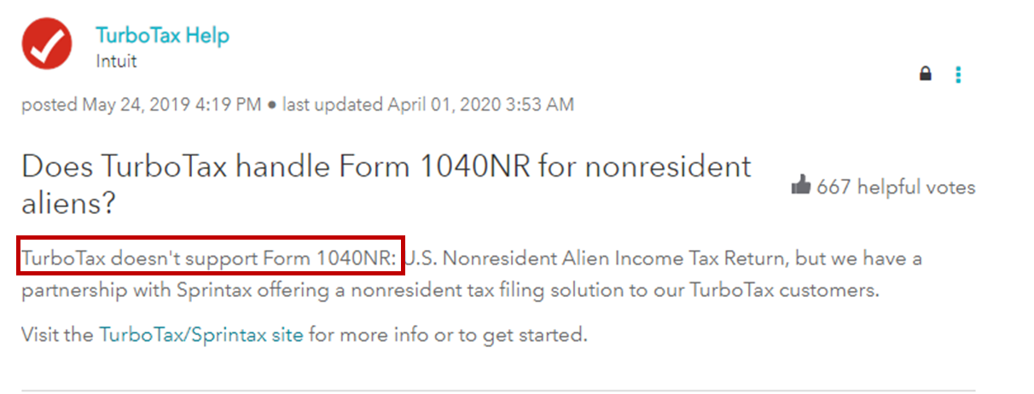

DO NOT USE A RESIDENT TAX RETURN PREPARATION SERVICE UNLESS YOU ARE CERTAIN THAT YOU ARE A RESIDENT FOR TAX PURPOSES

- Recommended next steps:

  - If you have received the Economic Impact Payment (stimulus check)
    - Check what tax return you prepared in 2018 or 2019
    - Was it a 1040 (for residents) or a 1040NR (for nonresidents)?
  - If it was a 1040 you filed as a resident for that year.
    - Log in to Sprintax
    - Sprintax will guide you through the substantial presence test and confirm if you were a resident or nonresident for that tax year

Complete the Substantial Presence Test for free with Sprintax
https://www.sprintax.com/?utm_ref=covidpartnersinfo
  - If you filed as a resident and Sprintax confirms you are a resident – no further action required at this moment
  - HOWEVER – If Sprintax finds that you are a nonresident then you should have filed as a nonresident – you need to prepare and send an amended tax return (1040X) to the IRS to correct this
  - Sprintax will help you prepare your amended return, for any year
    - We recommend you do this as quickly as possible
    - Once you have your Sprintax amended return, mail this to the IRS.
    - Separate to your amended return – return the stimulus payment. The IRS provide instructions here:
https://www.irs.gov/taxtopics/tc161

- Future possible implications:
  - Filing an incorrect tax return may cause fees and penalties to accrue with the IRS.
  - Incorrect tax filing will also impact a change of visa status or a future visa application – so please ensure now that you have prepared your taxes correctly for 2020 and previous years.

<SCHOOL> has partnered with Sprintax and paid for free federal tax return preparation for international students and scholars who are nonresidents for tax purposes.

If you are not using Sprintax – make sure you understand if you are a resident or non-resident for tax purposes and that you are not filing incorrectly.

